**Year 10 Psychology**

**Brain function and memory quiz (5%)**

**Student Name:**

1. What is psychology? [2 mark]

__________________________________________________________________________________

__________________________________________________________________________________

__________________________________________________________________________________

1. Label all 5 of the structures below, write one function of each structure [10 marks]

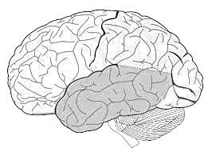

1. On the diagram above, circle the brain stem [1 mark]
2. Shea was speaking to her friend Ella in her local coffee shop when she heard “Savage Love” playing on the radio. Circle the sensory organ that detects the auditory sound from the external stimuli of the music. [1 mark]

Eyes Ears Skin Nose

1. Circle the word below that is not a model or approach used in psychology [1 mark]

Humanism Structuralism Deconstructalism Psychoanalysis

1. In 1848 a railroad worker named Phineas Gage had a metal rod blasted through his brain during an explosion. He survived but his personality and his behaviour reportedly changed dramatically after the accident. Suggest a reason for the change in his behaviour and personality [2 marks]

____________________________________________________________________________________________________________________________________________________________________________________________________________________________________________________________________________________________________________

1. Describe what a concussion is and how they occur. Choose one lobe of the brain and explain what would happen if a person suffered a concussion to that lobe. [3 marks]

_______________________________________________________________________________________________________________________________________________________________________________________________________________________________________________________________________________________________________________________________________________________________________________________

**End of assessment**

**TOTAL MARK /20**